Oge Funlola Modie (Ogechukwu Olufunmilola Modie) was born on the 12th of January, 1976 at the University College Hospital, Ibadan. “Oge” as she is simply known by friends and close associates was born to parents who were professionals; her father retired as the Associate Dean, School of Medicine at the University of Nigeria, Nsukka and her mother retired as the Chief Nursing Administrator at the University of Nigeria Teaching Hospital, Enugu.

Oge’s journey through life has been exemplified by impeccable timing as shown in her first name, “Ogechukwu,” which simply means “God’s time” in Igbo language. Her full name reveal a lineage from both the Western and Eastern part of Nigeria. Oge’s middle name “Olufunmilola” originated from her paternal grandmother who was Yoruba.

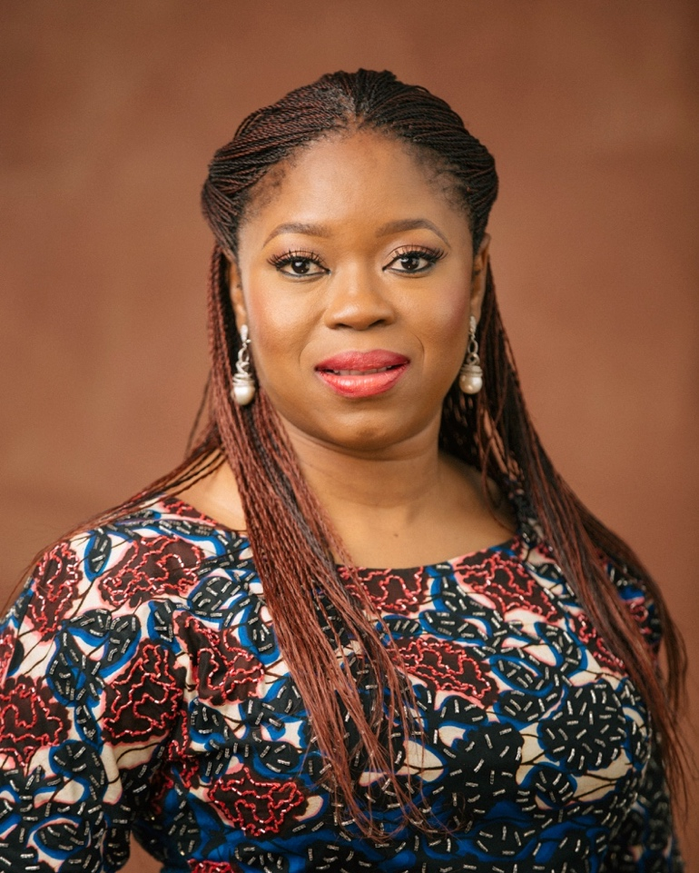
Oge was called to public service in August 2015 to serve in the capacity of Chief of Staff to the then Group Managing Director (GMD) of Nigerian National Petroleum Corporation (NNPC), Dr. Emmanuel Ibe Kachikwu. She was given the key responsibility of playing a lead role in the organization; provision of administrative and advisory support to the office of the Group Managing Director who was later nominated and confirmed as the Minister of State for Petroleum Resources, Federal Republic of Nigeria in November 2015.

By this second appointment, Oge’s responsibility as Chief of Staff doubled and this new challenge enabled her bring to bear her managerial dexterity in effectively managing both offices and delivering key results. Within the last few years, she has been a key part of the decision making process that has brought about the restoration of public and investor confidence in the state owned Oil Company. She currently plays a vital role in the team set up to ensure transparency, integrity and probity in the energy sector both within and outside Nigeria. With the promotion of her principal, Dr. Emmanuel Ibe Kachikwu to the position of the Chairman of the Board, Nigerian National Petroleum Corporation (NNPC) from the position of the Group Managing Director, she now doubles both as the Chief of Staff to the Honourable Minister of State, Petroleum Resources and Coordinator of the Ministry of Petroleum Resources’ Project Management Office charged with the implementation and provision of leadership direction for the 7 Big Wins – Nigerian Petroleum Roadmap of the Ministry which focuses on short and medium term priorities to grow Nigeria’s Oil and Gas industry.

Prior to her present position, Oge was the Managing Director/Chief Executive Officer of NOIPolls Limited for 3 years. She joined NOIPolls Limited in February 2012 as the Chief Operating Officer and was announced as the Managing Director/Chief Executive Officer in August 2012. At the time, she was the first and only woman to have headed a leading independent opinion polling and research organization in Nigeria. Under her leadership, NOIPolls grew in visibility across the West African Region and African Continent. The company won various awards; the Global Excellence Quality Award for the “Global Most Innovative Consumer Research and Data Analysis Company” for the year 2014 and the Pan-African Distinguished Achievers Awards (PADAA) for “West Africa’s Leading Opinion Polling Research Organization.” In 2015, the company also won the African Quality Achievement Award for “Africa’s Most Reliable Quality Opinion Research and Polling Service Provider,” the Nigerian Brands Organization’s “Most Innovative and Impactful Market Research Agency of the Year-Platinum Award” and African Development Magazine’s “Opinion Polling Company of the Year.”

Oge commenced her early career in 1999 with Agusto & Co Limited, Nigeria’s first indigenous credit rating company. Agusto & Co Limited then partnered its consulting arm with IBFC Consulting to become Alliance Consulting where she worked for six years as an Associate Consultant while building up her skills in West African Mergers & Acquisition Market, with a focus on the Nigerian and Ghanaian financial services industry (pre-consolidation era). She was also part of the academic faculty at the IBFCAGUSTO training school where she taught Treasury Arithmetic and Credit Analysis to Bankers in Nigeria. She left the Organization in September 2003 to join the HEIRS Alliance team, a portfolio company founded by Tony Elumelu.

She was the Manager, Corporate Venturing and Incubation at Heirs Alliance where she was part of the core team that managed the financial services portfolio (over US$5bn) of the Standard Trust Bank group of companies now United Bank for Africa. She was the project lead on various Mergers & Acquisition projects across the West African Region. During her time at Heirs Alliance, Oge’s key highlight was the planning, execution and management of a one-year US$4 million project covering acquisition, restructuring and management of a financial services company in the insurance sector. This led to the birth of one of the top insurance companies in Nigeria.

In mid-2005, Heirs Alliance was dissolved temporarily and the management formed a new company called Nextzon Business Services. At Nextzon, she was instrumental in designing the Nextzon Business Incubator, which warranted a grant from the World Bank MSME program.

On her return from business school in 2008, she joined Makeda Fund Managers LLC as the Fund Director (West Africa). She directly managed a US$50million SME private equity start up fund focused on investing in women entrepreneurs across West Africa. The fund was run in partnership with Small Enterprises Assistance Fund (SEAF) based in Washington, D.C. As the Fund Director, Oge generated interest in investing in women owned/managed SMEs across West Africa. She also provided technical assistance to these women-owned businesses, particularly those that needed support in their journey. She was responsible for fund marketing, relationship building & managing, deal sourcing and managing investor relationships. She left in 2012 to join NOIPolls Limited.

In 2009, she founded a company called Alternativ Managers; an SME focused consulting company that has partnered with the Ford Foundation, The Nigeria SME Agency (SMEDAN), LEAP Africa and Fate Foundation to build capacity in SMEs and stakeholders in the sector.

Oge earned a Bachelor of Science with Honors in Economics from University of Nigeria Nsukka (UNN). She attended the Cranfield School of Management where she was awarded a Master of Business Administration Degree. Oge is a joint Alumni of the Columbia Business School and Columbia University School of Arts where she participated in the 2018 Strategic Storytelling Workshop. She is a 2018 Alumni of the NNPC Leadership Academy where she participated in an Intensive Leadership Development Session. She has contributed to a wide range of publications- some of which are; The NESG Publication (2000), The NNPC News Magazine, The NNPC Quarterly Magazine, Per Second News and many others. She was a pioneer member of the Policy and Research Group (PARG) in the Economics Department of the University of Nigeria Nsukka whose Patron was Prof. Chukwuma Soludo.

Oge is a published author, teacher, writer, blogger, public speaker, radio host and avid golfer. She is also the founder of Wellspring of Life Global Outreach, Kairos Knowledge Centre, Heels of Influence and the First Born Foundation, whose core mission is to daily contribute to the overall wellbeing of individuals. Oge has dedicated herself to writing a weekly faith inclined devotional called WellSpring of Life and a personal leadership newsletter aptly named, Fearlessly Authentic. She also writes her monthly column “Becoming you” and quarterly column “The Little Things” for the NNPC (Nigeria’s State owned Oil Corporation) publications. She has authored a book “Waters For The Thirsty SoulTM – 52 Refreshing Ways to Deepen Your Relationship With God” published by the renowned Kachifo Limited. Her book was the first Faith Inspired Book to be published by the Company.

She is the Radio Host of “Waters For The Thirsty SoulTM – Radio Devotional”, aired across Nigeria in Lagos, Abuja, Enugu, Port Harcourt, Maiduguri, Kano and Kaduna. The program is an inspirational and soul lifting morning devotional that encourages life in Christ and strength building through trials. The programme reaches over 12 million listeners and has an active prayer line open to listeners.

Oge’s career spans Corporate Finance, SME Ventures, Private Equity, Opinion Research, Public Policy and Administration. Oge is a faculty member of the AiMP’s (Apostle in the Market Place) Change Agents Academy where she teaches the module “A Journey of Discovery”. Apostles in the Market Place is focused on being a strategic vehicle for nation building across the African continent starting from Nigeria through the transformation of the marketplace. She is passionate about advocating for causes on gender rights, youth development, economic growth and rights of people living with disabilities. She sits on various Boards which include Affirm, an organisation with focus on women and youth rights, Victorious Women, Digital Media Development Initiative, an organization that advocates for digital inclusion and free web, Cedar Seed Foundation with special focus on advocating for the rights of women and the disabled in the society and Noon Day Foundation which advocates in the area of the rehabilitation of Internally Displaced Persons (IDPs). She is a Steerco member of the Sustainability in the Extractive Industries (SITEI) Conference; an annual workshop, established and organized by CSR-in-Action, to bring together key stakeholders to discuss critical issues in the industries and stimulate meaningful exchange of ideas and best practices among key stakeholder groups and industry experts.

Oge loves to create (created Onu & Company for NOIPolls amongst many others), loves to write, listen to music, read comic books, as well as fiction novels crafted by African writers. She loves to volunteer for SME, entrepreneur, youth and women causes around the world and has been a speaker at various events, including; IFC Women’s Conference in Cairo, Egypt, Private Equity Conference in Nigeria, IFC/Federal Ministry of Health Nigeria Healthcare Summit, Business Day Women Conference, IWOW Possibilities Conference, Nigerian Economic Students Association (NESA) Award Dinner and AISEC – Association internationale des étudiants en sciences économiques et commerciales Events, Sustainability in the Extractive Industries (SITEI) Conferences and the London Business School’s Africa Business Summit.

Oge is a 2015 Distinguished Fellow of the Institute of Brand Management of Nigeria (FIBN), a 2015 Fellow of the Institute of Credit Administration (FICA) and a 2016 Fellow of the Institute of Corporate Administration (FCAI). In addition, she is a Class 2015 member of the African Leadership Network (ALN), an eclectic, inspiring and fast-paced gathering of hundreds of the world’s most influential leaders – crafting the future for Africa. She is also a member of the Nigeria Association of Energy Economists (NAEE). In a competitive selection process, Oge emerged as the winner of the Credit Management Director of the Year during the 2015 Nigerian Credit Industry Awards. She was conferred with an African Leadership Excellence Award by the African Leadership Magazine, United Kingdom in 2015 in recognition of her Leadership and Contribution to the Economic Growth of Nigeria. The University of Abuja Chapter of the National Economics Students Association (NESA) has thrice Awarded Oge for Exceptional Contribution to the Growth and Development of Economics (2015), Stellar Recognition of Philanthropic and Humanitarian Service towards Humanity (2016) and Firm Recognition of Tremendous Support to NESA (2017). She received a Certificate of Appreciation by the Petroleum and Natural Gas Senior Staff Association of Nigeria (PENGASSAN) Branch of the Petroleum Products Pricing Regulatory Agency (PPPRA) in 2016 for her contribution to the growth of the Nigerian Oil and Gas industry. Oge is a philanthropist and received a plaque of honor in 2017 for her partnership with the Social Welfare Network Initiative to add value to Internally Displaced Women and Children in Northern Nigeria as a result of the Religious Crises. She has been honored by the CSR-in-Action Advocacy for her leadership and service towards sustainable development in Nigeria in 2018. She is a 2018 recipient of the True Star Foundation for Excellence’s International Women Support for Peace, Ambassador of Peace Award for her laudable contributions towards Nigeria’s Growth and Development. In 2019, she received a Distinguished Personality Platinum Award and was endorsed as an Icon of Humanitarian Services by the Arewa Youth Assembly, the foremost youth group in Northern Nigeria.

Oge lives in Abuja.

